How To Fill Out The Bethesda Premier Cup Youth Weekend Match Report

MATCH REPORT LINK FOR BOYS: https://forms.gle/2K7jZ5XkS7brWxcA7
MATCH REPORT LINK FOR GIRLS: https://forms.gle/xDCo8Dr3o3Fsg45g9

Step 1: Before each game, go to your team’s schedule and write down the following information. (Please note: Please do not email us the PDF copy after the match. You must use the Google Form)
-Game number
-The name of the home team
-The name of the road team
-Exact Field location

Here is an example on what this information will look like when you are going through the schedule page in GotSoccer
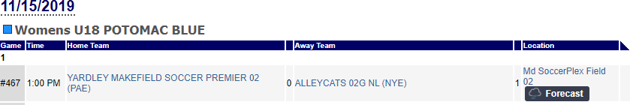
Step 2: Click the on the BOYS MATCH link (https://forms.gle/2K7jZ5XkS7brWxcA7 ) or the GIRLS MATCH LINK ( https://forms.gle/xDCo8Dr3o3Fsg45g9 ) and fill out the match report. We strongly encourage you to print the PDF copy of the match report and take notes during the game so that if there is an issue with WIFI at your field location you have it written down.
Step 3: Once you have filled in all of the required information hit Submit! If you run into any problems filling out the form email us at premiercup@bethesdasoccer.org

