BSC KOONS of SILVER SPRING PREMIER CUP
CHECK-IN INSTRUCTIONS

ON-LINE CHECK-IN:
- Check – On-line check-in due by:
  - Girls Weekend (U13-19): November 8, 2020 by 10:00 PM (Sun)
  - Boys Weekend (U14-19): November 15, 2020 by 10:00 PM (Sun)

- There will be no exceptions or extensions allowed!

There will be no on site check-in this year due to the COVID-19 safety guidelines. For extraneous circumstances, please contact your Age Group Coordinator (AGC) found on BSC Tournament Website under the Information tab.

- All teams that have successfully checked in on-line will have their stamped roster posted within their team GotSoccer account for download no later than:
  - Girls Weekend (U13-19): November 11, 2020 by 10:00 PM (Wed)
  - Boys Weekend (U14-19): November 18, 2020 by 10:00 PM (Wed)
- Instructions for on-line check-in can be found below:

INSTRUCTIONS ON HOW TO CHECK-IN ON-LINE:
- Print (or fill in) and sign the PDF document labeled “BSC Premier Cup Team Information Sheet.” The document can be found on the BSC Tournament Website under the team check-in tab.

- Documentation:
  - Teams need to provide:
    - 1 copy of the US Club Roster (please the logo for the US Club Soccer association and a sample US Youth Soccer Association)
    - (US Club Soccer Association)

    - (Example State US Youth Soccer Association)
    - A copy of each US Club Players Passes (ONLY front must be copied)
    - A copy of each guest players US Club Player Passes (ONLY front must be copied)
    - A copy of the guest players completed application form. The document can be found on the BSC Tournament Website under the team check-in tab or the Information tab
    - Read and sign the “BSC Guidelines/Policies/Rule Acknowledgement”. The document can be found on the BSC Tournament Website under the team check-in tab
    - US Youth Soccer Teams outside of Region 1 or from NJ need to provide a signed permission to travel form. Check with your State association for the appropriate form. (Region 1 teams include: ME, NH, VT, MA, RI, PAE, PAW, NYE, NYW, CT, MD, DE, VA, WV)
    - Premier Cup COVID Waiver Form/Participant Agreement Form (1 per team)
- After you have gathered the appropriate documents to register your team please scan or create PDF files for each document type (i.e., player cards, guidelines, team information sheet should all be separate files) as they will be uploaded separately. Ensure you use descriptive names so you will know which files to upload. We recommend scanning multiple player cards at one time to fill an 8.5” x 11” piece of paper and thus requiring fewer “Player Cards” attachments.
Follow the instructions below:
  - Login to www.gotsoccer.com with your username and password.
  - Select the Bethesda Tournament
  - Select “Documents”
  - Select the labels from the drop down list and upload the corresponding files.
- As we review and approve your registration materials, we will place green check marks next to your accepted documents within GotSoccer. Any documents we have problems with, will receive a yellow mark, your team will be marked with a “yellow flag” and comments will be placed in GotSoccer for you to address. Once we have accepted all materials, we will post your approved stamped roster on GotSoccer for you to download. You should plan on checking GotSoccer at least once a week for updates and then daily as we reach the deadlines for on-line check-in.

FREQUENTLY ASKED QUESTIONS
Check -In Confirmation:

If I checked my team in on-line, how will I know my roster has been approved?
Approved stamped rosters will be uploaded into GotSoccer for you to download under the “BSC USE ONLY: APPROVED On-Line Roster” label. This will be your official tournament roster. You MUST bring this to the tournament with you and show it along with your original player cards to the Field Marshal (FM) prior to every game. This file will be posted no later than one week prior to the tournament start date.

NOTE: If the Stamp Bethesda stamp does not display when you print your document, you must ensure that the “Documents and Markups” is selected under the “Comments & Forms” section highlighted in the image below for you.

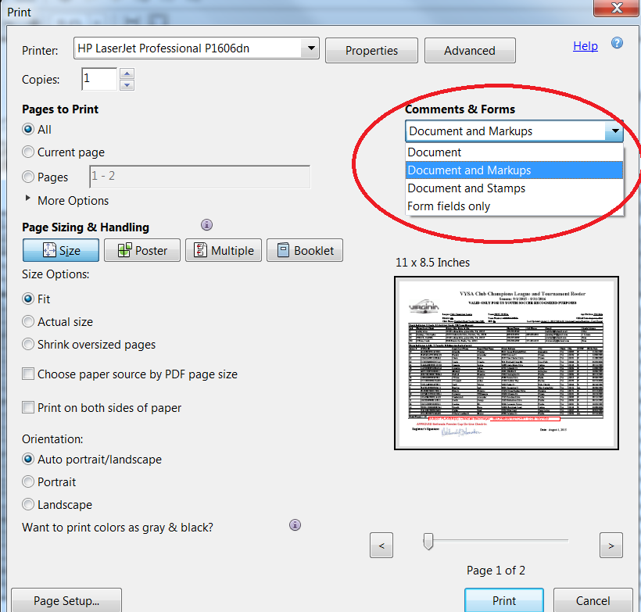

Players not attending the event:

If a player is not attending the event do I leave their name on the roster?
No, if a player is not attending the event; you need to cross their name off of the roster.
Guest Players & Roster Size:

What is the maximum number of guest players a team can bring to the event?
A max of three (3) guest players will be allowed.

The following are the maximum roster size per age groups:
U13 (11v11) – 18 players
U14 - U19 (11v11) - 22 Players, but only 18 may dress for any given game.

U13- U19 Teams
Rostered players may play for other teams within the same club without needing guest player approval! Allowing players to move within the Club teams helps them with injury coverage as well as tiering for tournament purposes. For example, a Bethesda Green player in the U11 age group can play on the U11 Bethesda Blue team without needing guest player approval.

How do I add a guest player?
Step 1: Obtain the guest players current player card and medical release form

Step 2: Photocopy your original roster. Handwrite the guest player’s full name, unique jersey number, player identification number and birthday below the bottom of the existing rostered players.
Note: US Club Soccer teams may only take guest players registered under US Club Soccer, and USYSA teams may only take guest players registered with properly stamped USYSA player pass cards. No roster may be comprised of players with different passes from different organizations (no “mixed rosters”).

How do I add a guest player after my on-line registration was approved?
Due to the size of the tournament, teams will not be allowed to resubmit their roster online unless permission is given by the registrar. This will depend on the workload of the registrar. Teams will be allowed to resubmit their roster in person during the on-site check-in dates and times. If your team needs to modify/resubmit their roster you must do so before the deadline or follow the directions for on-site check-in.

Medical Release Forms

Do I include the medical release forms in the early registration document?
- No. All teams must have a medical release form for each player (including guest players) but DO NOT include the medical release forms in the online registration package.

Do Medical Releases need to be notarized?
- No. Medical Releases DO NOT need to be notarized. However, you must have signed our rules and guideline form stating that you have medical releases for all of your players.

Age Group Structure
What Birth Years play in each age group?
(Remember, players may play up but they cannot play at an age group younger than their birth year, i.e., a player born in 2002 may play U18 or U19/20. They may not play U17.)

2002 – U19/20
2003 – U18
2004 – U17
2005 – U16
2006 – U15
2007 – U14
2008 – U13

How to “type” in the COVID Waiver (PDF file):

- Click on the COVID Waiver.pdf to bring up in Adobe Reader.
- Select “Fill & Sign” Option
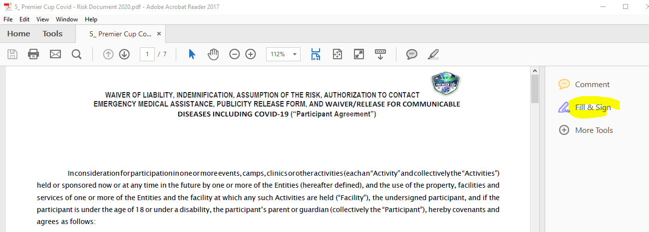

- Select “Ab” option to bring up a text editor box

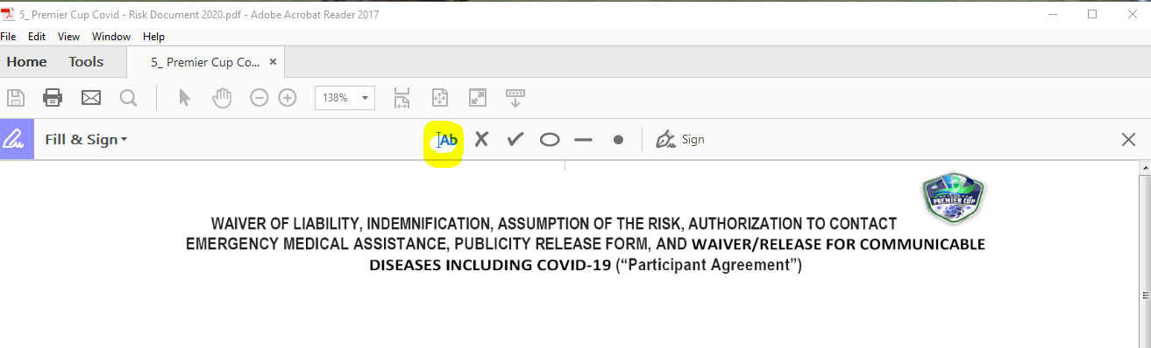
- Drag the editor box to a line and start typing in a text

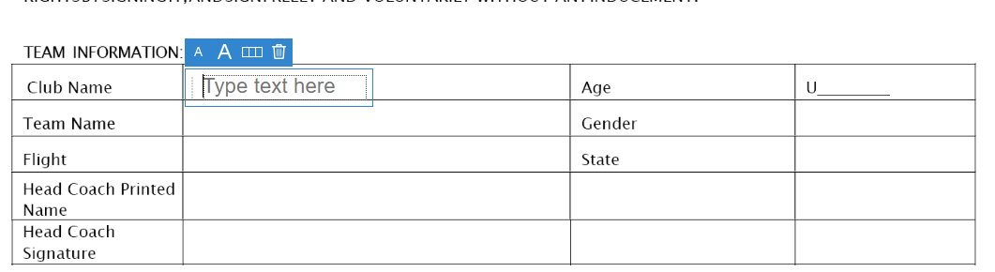

- See below

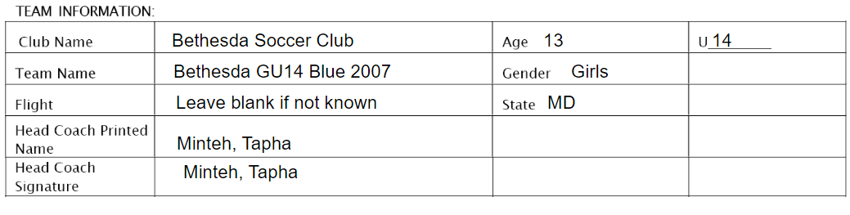

- Save back as a PDF
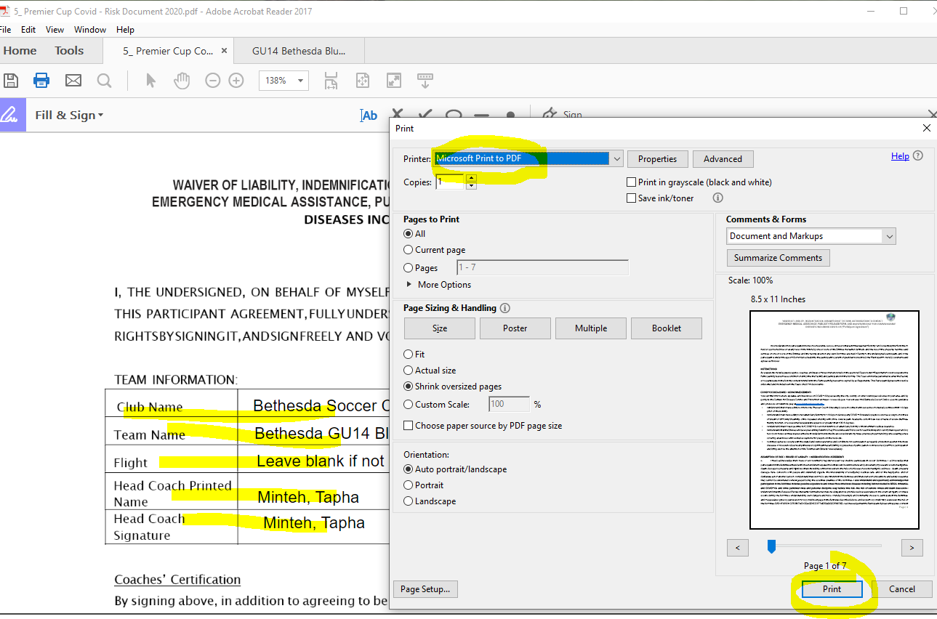

How to “digitally sign” the COVID Waiver (PDF file): (NOT RECOMMENDED)

- Click on the COVID Waiver.pdf to bring up in Adobe Reader.
- Select “More Tools” Option
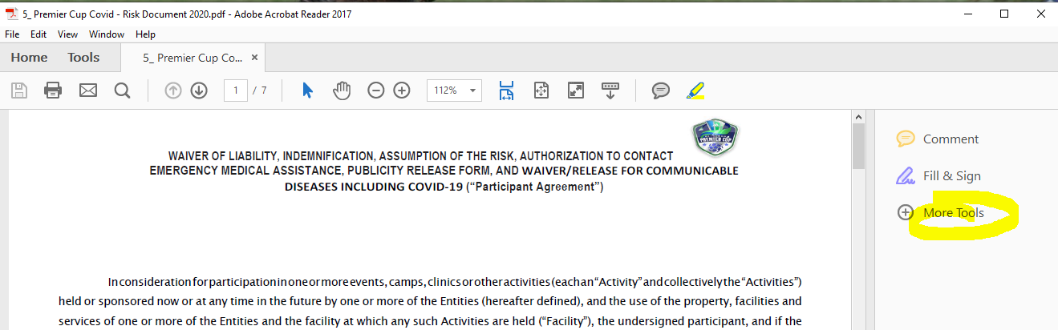

- Click on ”Certificate’ option
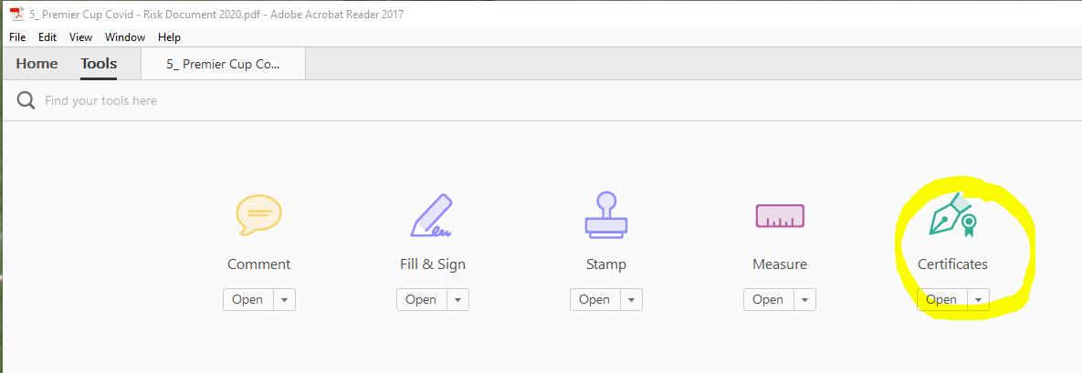

- From the Certificate tool bar, select Digitally Sign option below

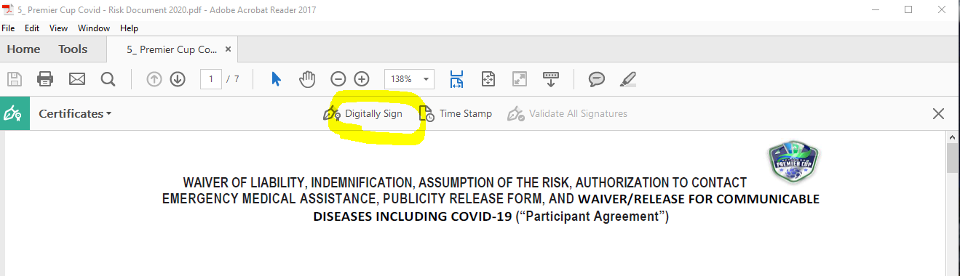

- You will see the follow pop up menu instructing you to drag a cursor to a location you want to digitally sign:
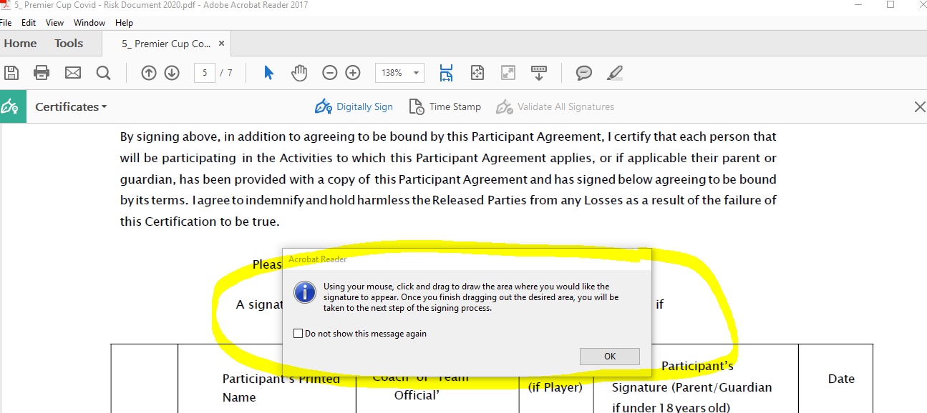
- Drag a place in a location for the signature/date pair, you will be prompt with your digital ID.

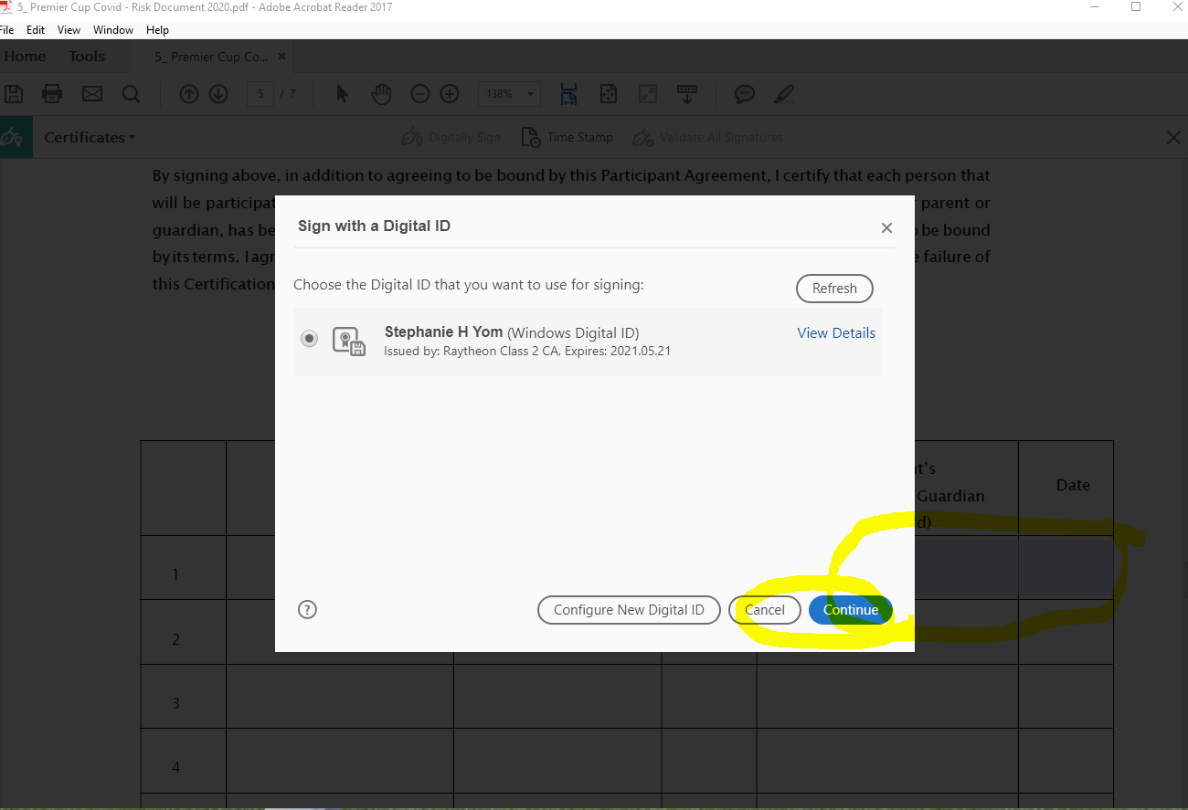

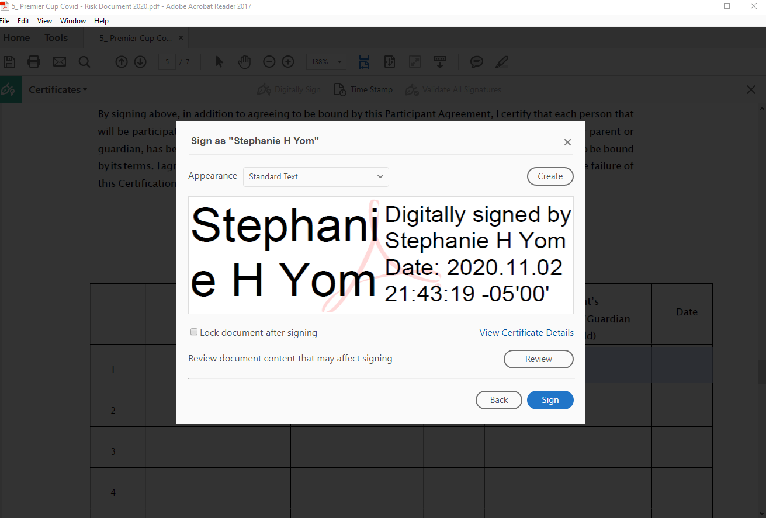

- Click on the Sign button above. You will find the following view with the overwrite option.
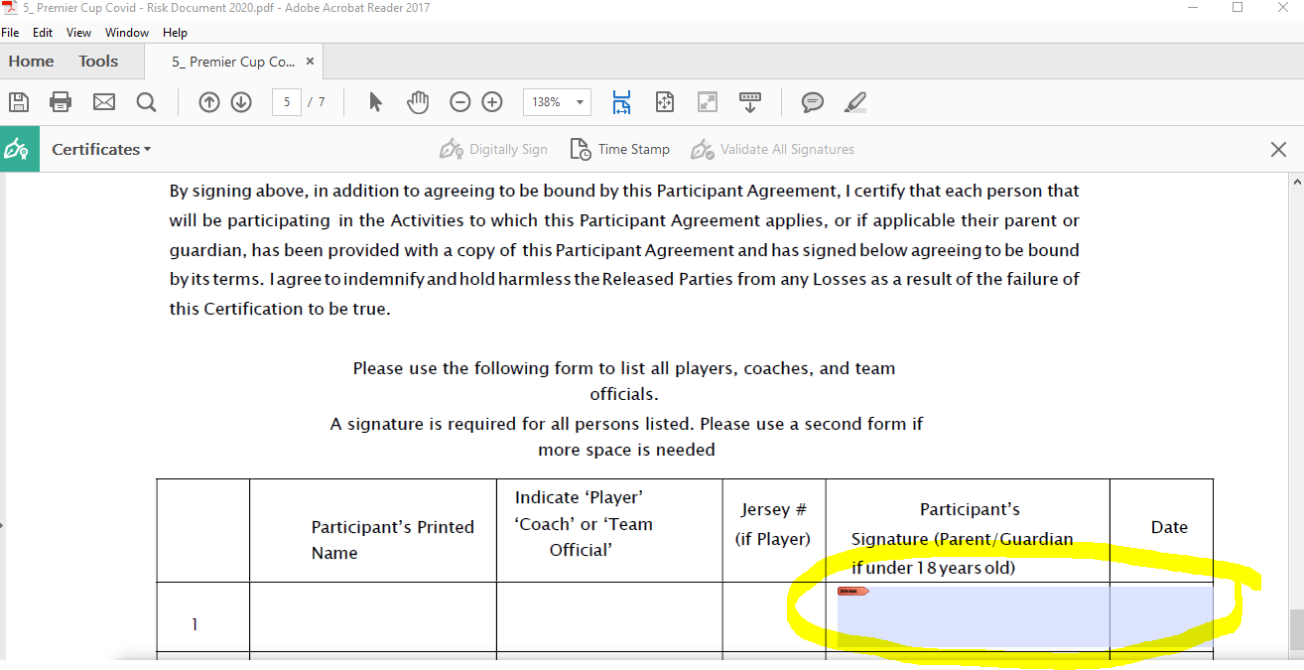
8 Open the saved pdf file to confirm that a digital signature has been placed:
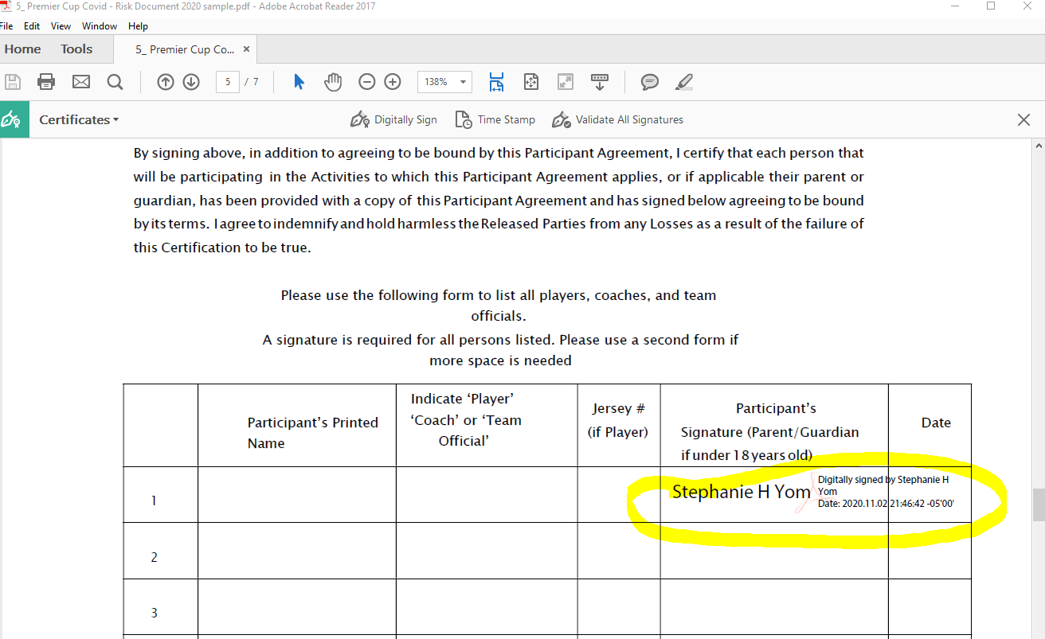

How to “sign” in the BSC Guidelines and Policy.docx into a PDF file:
- Click on 3_ BSC_Guidelines_Policy_2020.docx.
- Type in the bottom of the word docx.
- Print it back into a PDF
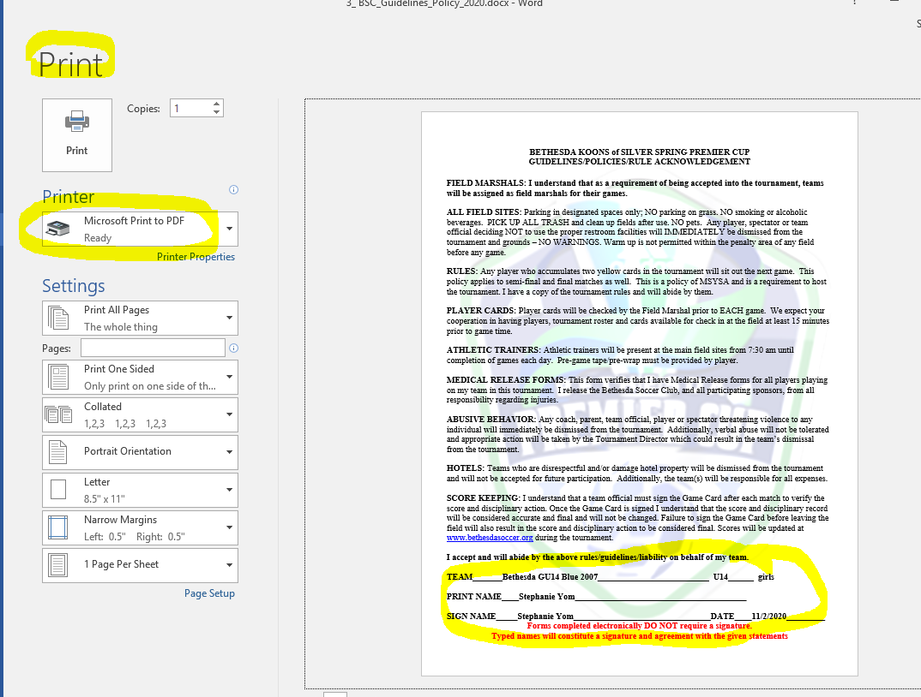

ALL QUESTIONS ABOUT ONLINE CHECK-IN CAN BE EMAILED DIRECLTY TO Bethesda Soccer @ checkin@bethesdasoccer.org

